The actual implementation from this code can be found here:
I have made minor changes in the code so as to make changes easily and also have updated model by increasing depth of the network. As a result, improved accuracy has been observed.

I have trained both model on CamVid dataset – 11 class and 32 classes. The trained model are avialable in folder as follows.
'ckp11_SegNet/' : This checkpoint is trained on CamVid 11 classes with 367 training images. The result of this model are given below:


'ckp32_SegNet': This checkpoint is trained on CamVid dataset 32 classes with 500 training images. The result of this training model is given bellow:
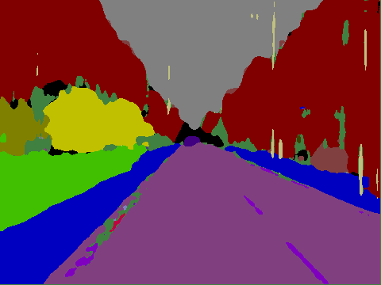

‘ckp11_myModel’: This checkpoint is trained on CamVid 11 classes dataset.

